Stock Demographic

Interface Requirements Specification

# The Tile Shop

# Contact Information

## Customer Contact

|  |  |  |
| --- | --- | --- |
| **Name** | **Tel** | **Email** |
| **Marcy Rasmussen** | 763.852.2994 | [mrasmussen@tileshop.com](mailto:mrasmussen@tileshop.com) |

## Integration Contact

|  |  |  |
| --- | --- | --- |
| **Name** | **Tel** | **Email** |
| Lea King |  | lking@tekpartners.com |

# Customer Confirmation

General

1. **Vendor Name:**Certent
2. **Confirm Group or Plan Number:**

n/a

1. **Will you have employees that are active in multiple component companies?**

☒ No ☐ Yes

1. **Which Employees would you like to include on this export?**☐ All Employees with Stock Awarded field checked– this appears to be a Platform configurable field as it’s not setup as a udf. See screenshot below.

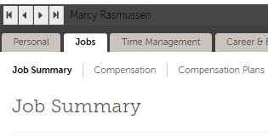



# Mapping/Notes to Developer

Include header

CSV format

Leave terms on for 90 days after eecdateoftermination